Name: ________________________________________ Date: ____________________________

PreCalculus: Calculus Intro Unit – HW C6-1 Visca

In Exercises 1–10, find the general solution to the exact differential equation.

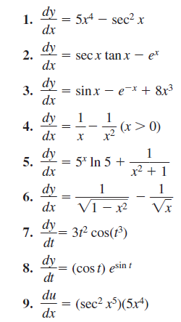

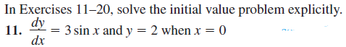









In Exercises 29–34, construct a slope field for the differential equation. In each case, copy the graph at the right and draw tiny segments through the twelve lattice points shown in the graph. Use slope analysis, not your graphing calculator.

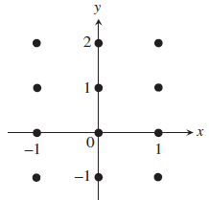











In Exercises 35–40, match the differential equation with the appropriate slope field. Then use the slope field to sketch the graph of the particular solution through the highlighted point (3, 2). (All slope fields are shown in the window [-6, 6] by [-4, 4].)

